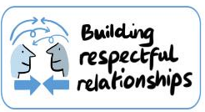
Children’s Complaints and Concerns Form
At Cafcass we are always looking at ways to make our service better for children and young people and we believe in respectful relationships. Your feedback helps us think about the things we are doing well at as well as the things we need to improve. Your feedback is really valuable to us, and we thank you for taking the time to share it with us. A Cafcass Complaints Manager will be on touch once we have received this form.
Name: | ChildFirst Ref Number:  Service area: Team:
- How happy were you that my first letter to you explained my role and how I would work with you and your family?

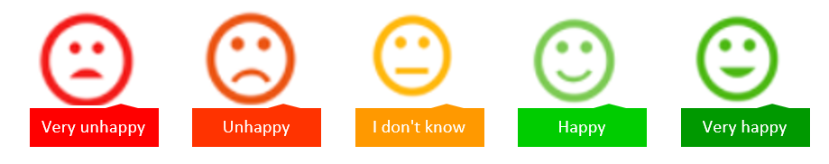
☐ ☐ ☐ ☐ ☐
What could have been done better?
- How happy are you that I listened to you?
Add your comments:

☐ ☐ ☐ ☐ ☐
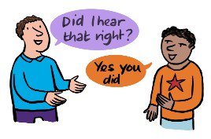
What could have been done better?
Add your comments:

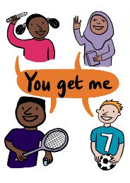
- How happy are you that I respected and understood what was special about you and your family?
☐ ☐ ☐ ☐ ☐

What could have been done better?
Add your comments:

- How happy are you that I reported (told the family court) your wishes and feelings in your own words?
☐ ☐ ☐ ☐ ☐

What could have been done better?
Add your comments:
- Please let me know how well I explained my thinking and recommendations to you.

☐ ☐ ☐ ☐ ☐

What could have been done better?
Add your comments:

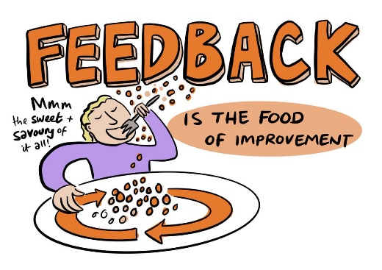
Is there anything else you’d like to tell me about how well I worked with you and your family?
Add your comments:
- How happy are you that I helped you and your family?
☐ ☐ ☐ ☐ ☐

Please tell me how I made a difference? What were the most helpful things I did?
Add your comments:

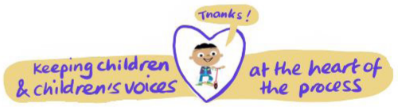
What could have been done better?
Add your comments:

